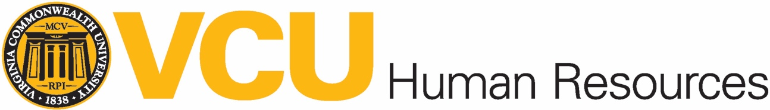
Career Development Plan
Please collaboratively work with your manager to complete this form. Additional instructions are provided on the reverse side to guide you.
Name: _________________________________________ Career Development Plan Period (begin and end dates): _______________________________
Current Position: _______________________________ Time in Current Position: _________ Name/Title of Manager: _____________________________
- Identify your career objective: __________________________________________________________________________________________________
____________________________________________________________________________________________________________________________________________________________________________________________________________________________________________________
EXAMPLE 1: I am interested in gaining additional skills in human resources and preparing to complete the SHRM CP/SHRM SCP professional certification.
EXAMPLE 2: My goal is for more confidence in public speaking to further skills in current position and speak comfortably in large settings.

- Identify your goals, development, learning methods, resources and target dates for achieving goals in the chart below:
 | A. Goals, Aspirations or Areas of Interest | B. Competencies/Skills/Knowledge/  Experiences Needed  (Areas that I need to develop to meet goal) | C. Learning Methods (How will I gain the understanding, skills or experiences I need?) | D. Needed Resources  (What resources will I need in order to make progress toward this goal?) | E. Target date
EX. 1 | Interested in becoming an HR manager and need to seek additional skills. | Competencies from SHRM – communication skills, relationship management, ethical practice, HR knowledge, business acumen, consultation skills, leadership | - VCU’s Corporate Education courses – prep courses for the SHRM CP/SHRM SCP exam  - Take the exam | - Seek additional leadership opportunities/Stretch assignments  - Shadow other HR experts  - Participate in HR career community  - Study/practice for exam | 1/1/2019
EX. 2 | Public speaking | - Ability to speak confidently in front groups  - Ability to organize points appropriately  - Ability to engage and interact with audience | - Attend the Toastmaster at VCU | - Ask to lead a meeting  - Practice with others  - Agree to do presentation with small groups  - Prepare materials  - Seek feedback,advice,tips | 8/30/18
1
2
3

Signature of Employee/Date: __________________________________ Signature of Manager/Date: _________________________________
Instructions for Creating a Career Development Plan

Please use this document as a guide to complete the career development plan form. The form will be used until it is made available electronically within the Talent@VCU system.
Prior to meeting with your manager, develop your career objective and identify at least one career development goal. The plan addresses personal and career needs related to your current position or to prepare you for future career interests and aspirations. The plan identifies specific opportunities to help you obtain knowledge, skills and abilities in the coming year. Once you have created a draft plan, schedule a meeting with your manager to discuss the plan. It is important that you and your manager have a conversation about your career development interests and confirm the details of the plan. Once agreement has been reached, both you and your manager sign and each keep a copy for your files.
Steps
- Identify a career objective: Construct a statement describing your career under the best of circumstances. This statement should reflect the ideal version of your career. Include a sentence that inspires you to be your best and to strive for your highest potential.
- Identify the following:
  - Goals, aspirations or areas of interests: We recommend using the SMART goal format. Please consult the Performance Management Guidelines for full examples and details on how to create effective SMART goals (pages 7-11). They can be found at the following web link:
https://hr.vcu.edu/media/hr/documents/guides/PerformanceManagementGuidelinesIntroductionGoalDevelopment.pdf
S-Specific
M-Measurable
A-Achievable
R-Results Focused
T-Time Bound

  - Competencies, skills, knowledge or experiences needed: Consider the areas that may need to be developed to achieve your goal.
  - Learning methods: Identify how you plan to accomplish the goals. Learning methods include formal or informal training and education, on the job learning/stretch assignments, and other activities such as engaging in mentoring, coaching, career community activities, professional organizations, developing and delivering presentations, joining/leading projects, etc.
  - Identify necessary resources: What resources will be needed to make progress toward your goal? Consider resources such as – budget, time, equipment, etc.
  - Target date: Determine a reasonable timeline collaboratively with your manager.

