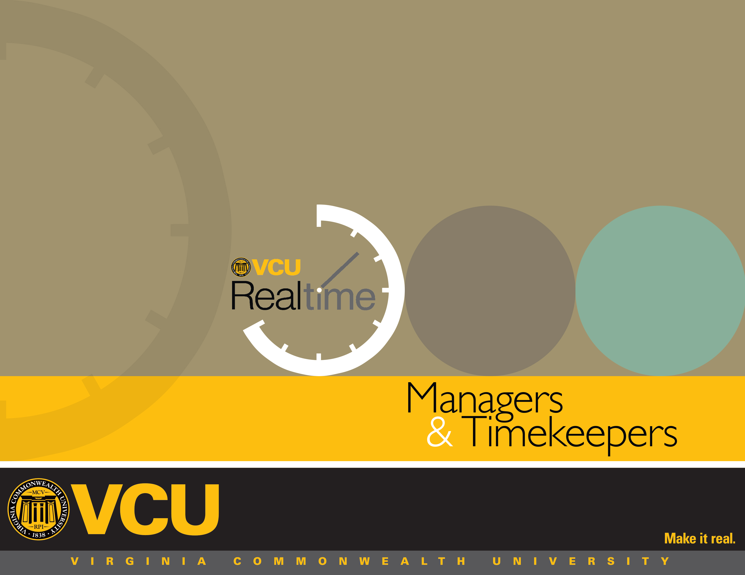
2
2
3
3
4
5
5
6
6
7
8
10
10
11
13
13
14
15
15
15
15
16
18
19
Table of Contents

Introduction to VCU RealTime
Roles and Responsibilities
Key Terms
Accessing VCU RealTime
Dashboard
Editing Employee Hours – Individual Hours
Adding Hours
Editing Hours
Cost codes for Grant-funded Positions
Reviewing and Approving Missed Punches
Approving Leave Requests for Faculty and Classified Staff
Modifying Leave Requests Prior to Approval
Editing Approved Leave Requests
Splitting Segments
Approving Hours Worked
Group Hours
Rounding
Other Information for Managers and Timekeepers
Approved Office Closings and Delays for Non-exempt Classified Staff Overtime for Non-exempt Classified Staff
Holidays
Reports and Criteria Messaging
Glossary

Managers
& Timekeepers

Introduction to VCU RealTime

What is RealTime?
VCU RealTime is the university’s time recording and leave processing system. It replaces paper forms and eliminates redundant keying of information into prior systems that did not link together.
The RealTime system helps to ensure accuracy and compliance with the Fair Labor Standards Act (FLSA). As the name indicates, the system tracks employees’ time worked as it happens, not after the fact, and is thus more accurate. The following is a list of some of the advantages of using an electronic timekeeping system like RealTime:
- It’s paperless.
- It ensures we are in compliance with FSLA.
- Users can view real-time hours and time history.
- Reports can be easily created.
- It stores work history so you can access it later.
- Managers can more easily monitor attendance, overtime, and leave usage. The responsibilities are not new, but RealTime makes it easier.

Who uses RealTime?
- Non-exempt employees use the system to record hours worked, either by clocking in and out or using the “Manage Time Sheet” option.
- Leave-eligible employees (exempt and non-exempt) use RealTime to request leave.
- Timekeepers and managers have specific monitoring, review, and approval responsibilities that are outlined and delineated below.

Roles and Responsibilities
Manager and timekeeper roles and responsibilities for reviewing and approving employees’ recorded work hours and leave requests remain largely the same with the VCU RealTime system as they were with the paper timekeeping system:
Managers monitor, review, correct and approve hours worked, overtime and leave requests.
Managers are ultimately responsible for monitoring and approving their employees’ work hours and leave requests. VCU RealTime also allows managers to correct timekeeping errors when employees are unable to do so and to approve a timekeeping error (i.e. a missed punch that an employee has corrected).
Timekeepers review employees’ recorded time worked, and leave requested/taken, to ensure it is compliant with policy.
Timekeepers review work hours for hourly and non-exempt employees to be sure they are equal to the expected work hours for the period. If a non-exempt classified employee is eligible for overtime leave accrual, the timekeeper will update their hours worked over 40 to the correct code; if a non-exempt classified employee works less than the expected hours, he/she should have leave entered for the missing hours.
There may be instances in which a timekeeper will perform timekeeping actions that are typically manager responsibilities. While this user manual identifies most of the system functions as manager responsibilities, timekeepers must learn and understand the same processes so they can perform them on the rare occasions that it is necessary.
****Failure to approve entries by manager before payroll deadlines may result in incorrect pay for non-exempt employees. ****
****Failure to use the system correctly can result in disciplinary action or department fines, depending on the type of noncompliance. ****
Remember the supervisor’s “DYNAMIC DUO”: Missed punches and leave. Get in the habit of checking for both every single day.

Key Terms
RealTime employee number – An employee’s unique identifier in RealTime, found by replacing the V in the VID with a 9 (e.g. an employee whose VID is V00123456 would have the RealTime number 900123456).
Clock in – a clock in initiates the system to record an employee’s hours worked. Clock in is used at the start of a work day or shift and after returning from a meal break and is similar to the “time in” term used on the paper timesheet.
Clock out – A clock out ends the system tracking of an employee’s hours worked. It is only used at the end of the work day or shift and is similar to the “time out” term used on the paper timesheet.
Break – Time not worked for lunch or meal. Meal breaks are unpaid and non-exempt employees should clock out for the meal break using the “Break” button and not the “clock out” button. This is not the discretionary “15-minute” break that some departments may permit.
Missed Punch – Employee failed to either clock in for work, clock out after work, clock out for a meal break or clock in upon returning from a meal break.
Segment – A period of time worked or leave recorded in RealTime. For example, most full-time employees will have two segments each day, one before the meal break and one after. Segments can be edited, added or split. Segments cannot be deleted.

Time Sheet – Record of time worked and approved leave. Non-exempt employees who do not clock in and out use the “Manage Time Sheet” function to record their hours worked in RealTime.

For more terms used in VCU RealTime, see the Glossary at the end of this manual.

Accessing VCU RealTime
Faculty and staff access VCU RealTime to record time and request leave by going to www.go.vcu.edu/realtime and clicking on the Employee link. (Certain departments may use physical clocks. Instructions for using physical time clocks are available from Human Resources.)
To access VCU RealTime as a timekeeper or manager, visit www.go.vcu.edu/realtime. Click on the Manager or Timekeeper link. Your eID and eID password will be required to log in. Please note that, for security reasons, the system will log you out after 15 minutes of inactivity.

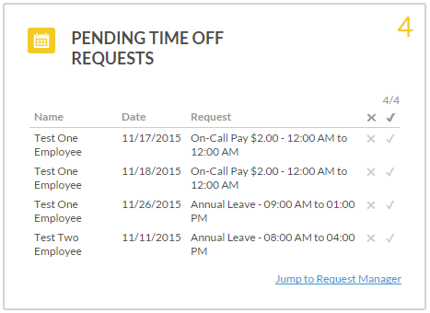
Dashboard
RealTime provides several tools to allow managers to view and approve information as soon as they log in through dashboard widgets.

Types of Widgets

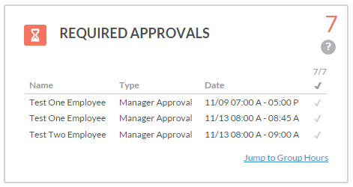
The Required Approvals widget displays time that has not yet been approved across the current open week period. A manager can approve by clicking the check mark, or “Jump to group hours.”

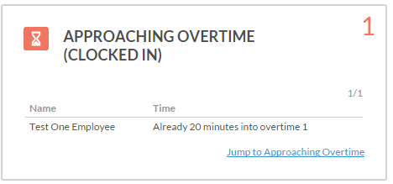
The Approaching Overtime widget is similar to the Approaching Overtime report. Employees within a certain threshold of hitting overtime will be displayed, along with how many minutes they have worked over 40 hours.

The Pending Time Off Requests widget displays employees who have upcoming time-off requests still requiring approval from the manager. The manager can approve or deny requests within the widget by simply clicking the x or the check mark, or click “Jump to Request Manager” to go directly to the Request Manager.

The Missed Punches widget displays missed punches that have been entered by employees but not yet approved by the manager.
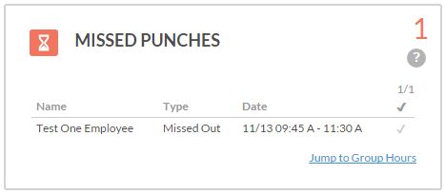

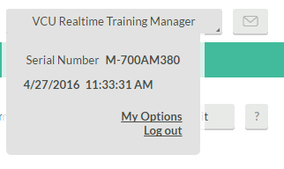
Note: The dashboard is configured to display 100 employees by default. If you have access to a large number of employees, you may want to increase this number. Click on your name in the upper right corner of the screen, and go to My Options. Edit the number in the Dashboard processing limit and click Save.

Individual Hours
Managers use Individual Hours to add, edit, and split employees’ hours, as needed.

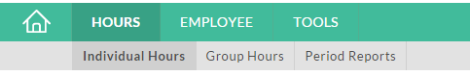

Adding Hours
It may be necessary to add a time segment when an employee fails to record hours for the entire day or fails to submit a leave request and payroll is closing.

1. Go to Hours > Individual Hours.
2. Click on an employee to view hours, or search for an employee by name or employee number (replace the V in the VID with a 9).
3. Click the Add Segment button.
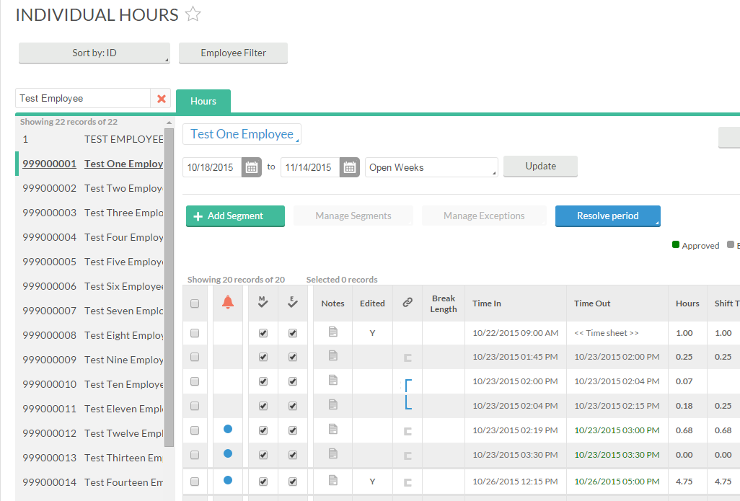
4. Enter the date and time of the segment
- The dates shown will default to today’s date for both time in and time out, and the default time in and time out are 9 a.m. and 5 p.m.
- Change time and/or date.
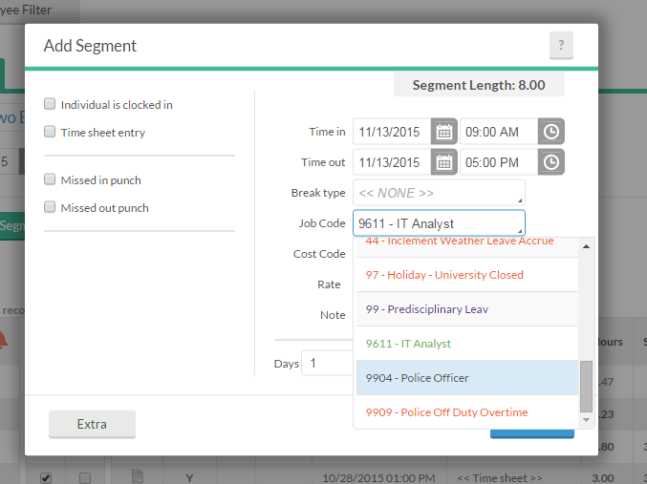
If the employee has more than one job, select the appropriate Job Code using the drop-down menu.
5. Enter a comment in the Note field.
6. Click Save when finished.
7. Once a record has been edited, a Y will appear in the Edited column. Click on the Y to view a note identifying the change made and the Employee Number of the individual who made the adjustment.

Editing Hours
It may be necessary to change times, dates, and job codes if an employee failed to do so or made an error.

1. Go to Hours > Individual Hours
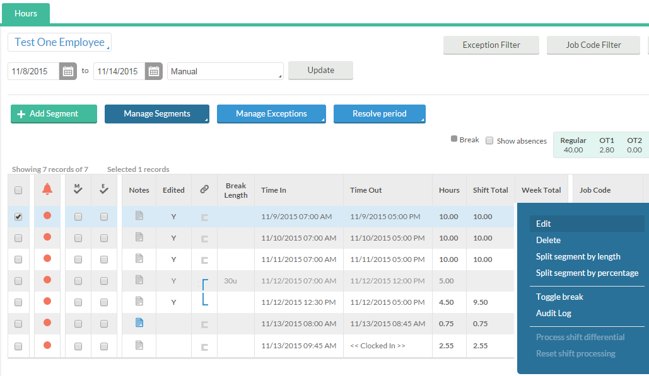

2. Click on an employee to view hours, or search for an employee by name or employee number (replace the V in the VID with a 9).
3. Right-click the segment that you wish to edit and select Edit. 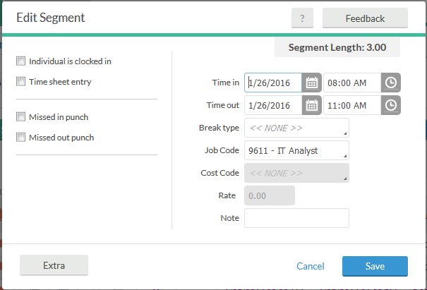

4. Make the desired changes, which could include:
- Editing date in, date out, time in or time out
- Selecting correct job code to record leave
5. Enter a reason for the edit in the Note field if desired.
6. Click Save when finished.
7. Once a record has been edited, a Y will appear in the Edited column. Click on the Y to view a note identifying the change made and the Employee Number of the individual who made the adjustment.

Zeroing out a segment
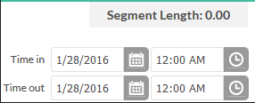
To zero out a segment that was entered in error, change the Time In and Time out to the same time (prior to the time the employee worked) and verify that the Segment Length is 0.00.
Note: ONLY PAYROLL CAN DELETE A SEGMENT.

Cost Codes for Grant-funded Positions:
For wage employees, timekeepers can adjust the labor distribution by updating the cost code from the default code to the index code of the grant.
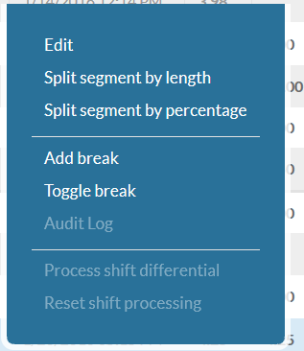
- Go to Hours > Individual Hours
- Click on an employee to view hours, or search for an employee by name or employee number (replace the V in the VID with a 9).
- Right-click on the segment and choose Edit (to update the full segment) or Split segment by length (to split segment into multiple cost codes).

- Under Cost Code select the desired index code for the grant. (Note: To narrow the search start typing the index code number.)
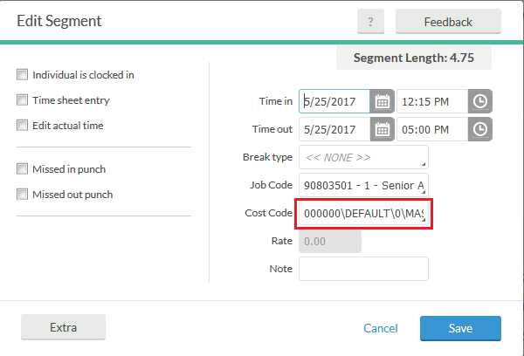
- Click Save when finished.
If the cost code is not updated in RealTime before payroll closes the timekeeper will need to complete the changes in Banner using Labor Redistribution (PHAREDS).

Reviewing & Approving Missed Punches
The “missed punch” system is designed to catch errors if an employee forgets to clock in or out. If an employee forgets to clock out at the end of a shift and then tries to clock in the next day, the system will recognize that a punch is missing and prompt for a correction.

Managers must approve all instances in which an employee missed and corrected a “clock in” or “clock out” either at the beginning or end of the day, or over a meal break. Employees cannot correct more than one missed punch in a row. Multiple consecutive missed punches must be corrected by the manager.

Missed punches that are not corrected can result in overtime or possibly errors that impact several segments. It is critical that missed punches be corrected in a timely manner. So remember the supervisor’s...
“DYNAMIC DUO”: Missed punches and leave. Get in the habit of checking for both every single day.

1. Go to Hours > Individual Hours. Missed punches appear in color. Click on the row with the missed punch to select it. A check will appear in the first column.
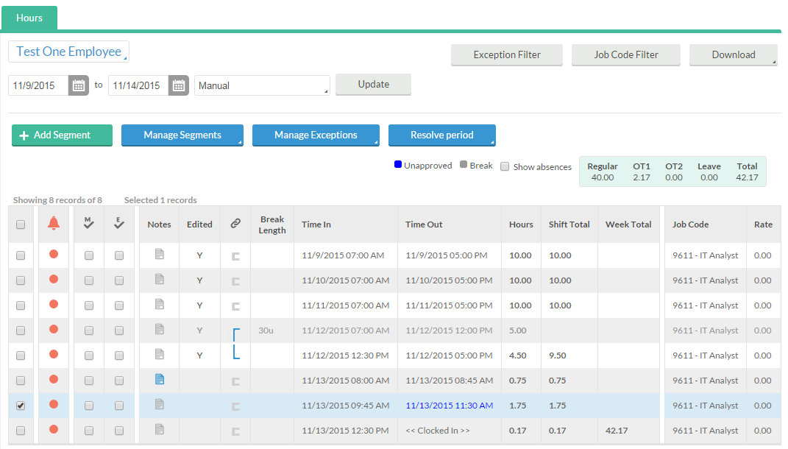
2. Click Manage Exceptions. Click the buttons in the Approve column to approve missed punches and add Manager approval for the shift. Click Apply.
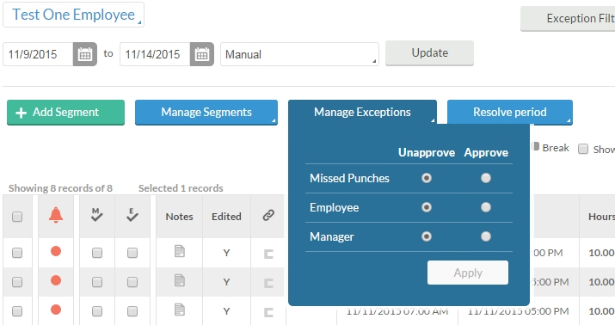
- Missed punches that have been fixed by the employee, but not yet approved by the manager appear in a different color, listed as “unapproved” in the color key above the timesheet.
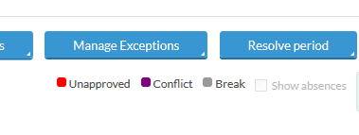

- Once approved, the shift will no longer be in the “unapproved” color.
If it is necessary to make an edit to the time the employee entered, right-click the segment, and choose Edit from the menu. The Edit Segment window will appear.
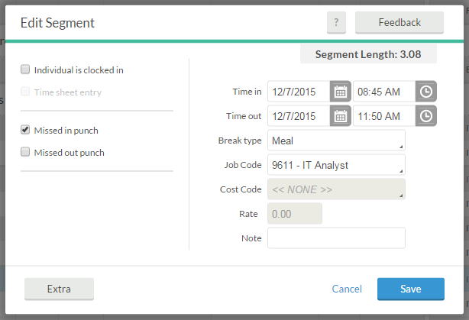
NOTE: Employees who record their time worked using the “Manage Time Sheet” option will not have missed punches.

Approving Leave Requests for Faculty and Classified Staff
In VCU RealTime, managers can perform three functions when they receive an email or a RealTime system request to use leave from faculty and classified staff. They can:
- Approve or deny the leave request.
- Modify a leave request that has not yet been approved. However, if the supervisor has not yet approved the leave request, the employee can cancel it and submit a new one.
- Change an approved leave request.

Leave requests for faculty and classified staff must be approved in a timely manner. Once a leave request is approved, the employee’s timesheet will be updated the following day. Failure to approve requests may result in the employee’s pay being incorrect.
1. Go to Tools > Request Manager. 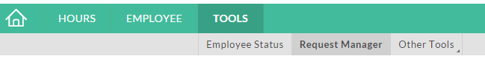
2. Leave request are displayed in a calendar. Click List to switch to list view.
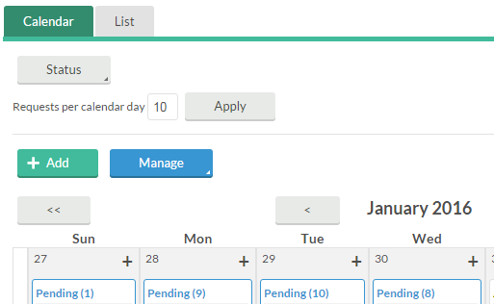

Check only the Include pending check box under Status to view only leave requests that have not yet been approved.
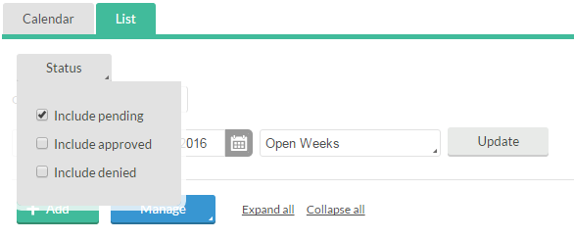

3. This screen shows all leave requests for all employees. View the list of requests in a different order by choosing from the Group by menu.
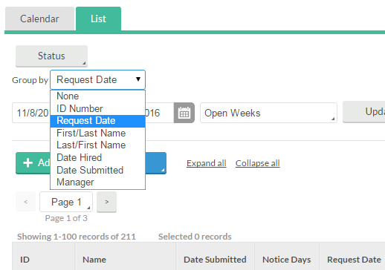
Select the request you wish to approve by clicking on the row. Click Manage then Approve Request Level 1 or Deny. The employee will be sent a standard message stating that the request was approved or denied.
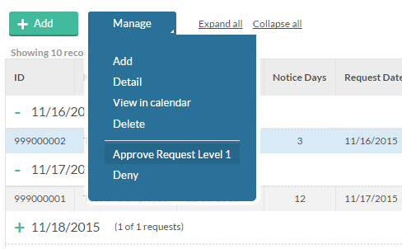
Modifying Leave Requests Prior to Approval
To make a change to the request before approving, choose Detail from the Manage menu. On the Employee Request Detail window, click Edit to go to the Employee Request.
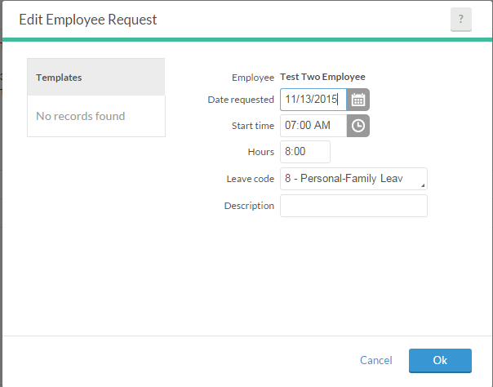
Make any appropriate changes and click Ok, which will return you to the Employee Request Detail window. Click Save.
Approving multiple days: It is possible to approve multiple days of leave for a single employee at one time. On the Request Manager screen, select the first row you wish to approve, then hold down the shift key while selecting the last row you wish to approve. Select Approve Request Level 1 from the Manage menu.
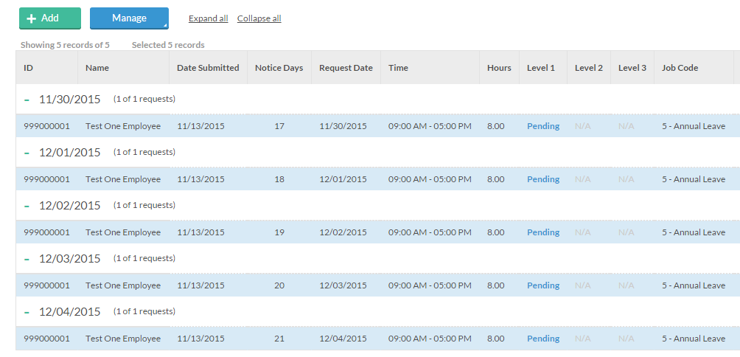
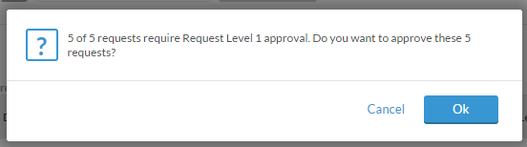

Editing Approved Leave Requests
It may be necessary to edit a leave request for an employee who requested the wrong type of leave, or keyed in the wrong hours, or requested leave that they ended up not taking. Once the manager has approved the leave request, ONLY the manager or timekeeper can make changes. Note that if an employee enters a leave request that conflicts with an existing request the system will not allow the conflicting request to be submitted. The system will display an error that says, “This requests conflicts with an existing request.” In this case, the manager must make changes to reflect the correct leave or earn code(s).
1. Go to Hours > Individual Hours
2. Click on an employee to view hours, or search for an employee by name or employee number (replace the V in the VID with a 9).
3. Right-click on the approved leave segment you wish to edit, and choose Edit. The Edit Segment dialogue box will open.
4. Edit the details of the leave request. Click Save.
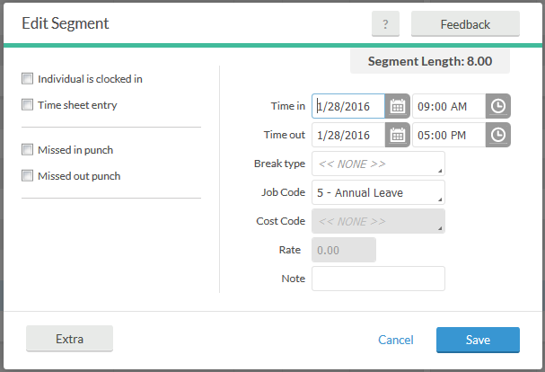
5. Once a record has been edited, a Y will appear in the Edited column. Click the Y to view details of the change made.

Zeroing out a leave request
To zero out a leave request that an employee no longer needs, change the Time in and Time out to the same time (prior to the time the employee worked) and verify that the Segment Length is 0.00.

Splitting Segments
Hours worked by non-exempt employees must be approved by the manager. Managers should not approve hours until all necessary edits have been made. Communication between managers and timekeepers is important, to be sure that timekeepers have completed any editing before the hours are approved. If a segment is edited after it is approved, the revised segment must be approved again.

A record may be split into different segments if necessary.
- Add a meal break if an employee failed to clock out for lunch and clock in.
- Change a job code: When a non-exempt employee works over 40 hours in a week, the timekeeper may split a segment to change the job code from regular earnings (REG) to overtime leave accrued.

To add a meal break:
1. Go to Hours > Individual Hours
2. Click on an employee to view hours, or search for an employee by name or employee number (replace the V in the VID with a 9).
3. Right-click on the segment and choose Add break.
4. Enter the Break length and Save.
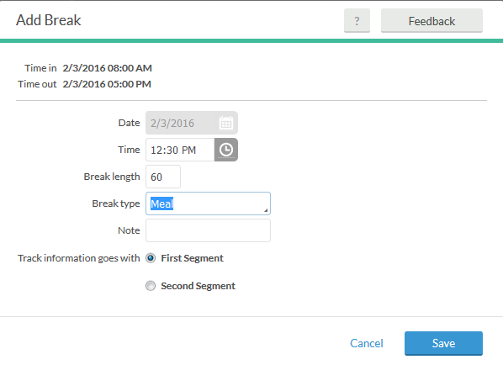
To change a job code:
1. Go to Hours > Individual Hours
2. Click on an employee to view hours, or search for an employee by name or employee number (replace the V in the VID with a 9).
3. Right-click on the segment and choose Split segment by length.
4. Click the Split button. The segment will be split into two equal segments.
5. Leave <<NONE>> as the Break type, enter the length of the first shift, then change the Job Codes as appropriate. In the example below, the employee worked a 5.5 hour segment, and went into overtime after 2.5 hours. The length of the first shift is 2.5 hours, and the Job Code on the second (2 hour) segment is changed to 22 – Overtime Leave Accrued.
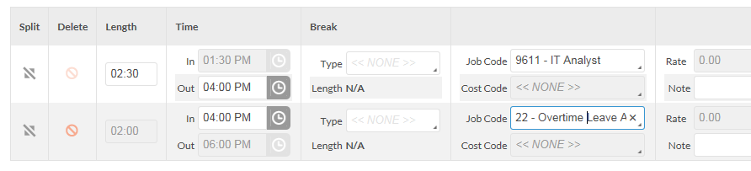
6. Click Save.
7. Once a record has been split, a Y will appear in the Edited column. Click the Y to view details of the change made.
Approving Hours Worked
Hours worked by non-exempt employees must be approved by the manager. These hours may be approved in Individual Hours or in Group Hours.
Approving Hours in Individual Hours
(to approve hours for one employee at a time)

1. Go to Hours > Individual Hours
2. Click on an employee to view hours, or search for an employee by name or employee number (replace the V in the VID with a 9).
3. Check the boxes under the M column to indicate manager approval. Two new boxes will appear: Apply Changes and Discard Changes.
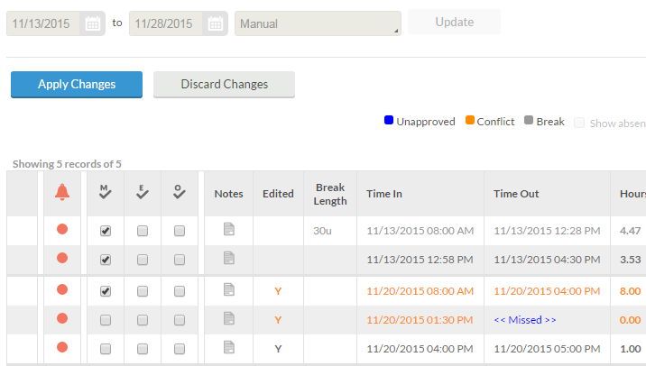

Click Apply Changes to approve the checked segments.

Approving Hours Using Group Hours
(to quickly assign approval to multiple shifts or multiple shifts for multiple employees)

1. Go to Hours > Group Hours.
2. Enter the desired range in the Start and End date fields, or select a date range from the drop-down list. Click Update.
3. Review the hours and verify that they are correct. If corrections are required, double-click on the segment to open Edit Segment and make the necessary corrections, or notify the timekeeper to correct the hours before proceeding with approval.
4. To indicate Management approval for a particular employee, click the check box below the M column. To select and approve multiple segments or employees, select the first row, then hold down shift key while selecting the last row, then click Manage Exceptions and choose Manager.

Note: Shifts that have not been approved may not be exported to Banner. All shifts should be approved prior to the day the Payroll office exports time into the Banner system. For dates, refer to the Payroll processing schedule on the Human Resources website: www.hr.vcu.edu Failure to approve shifts may result in loss of employee pay.
Rounding
For employees who clock in and out, the RealTime system is recording the employee’s exact time in and time out. Those hours will be displayed rounded to the nearest quarter hour.

RealTime is designed to round employee clock-in and clock-out actions to the nearest 15 minutes, just as employees have been instructed to do on paper timesheets.
- Non-exempt employees are paid for hours worked, and it is important to realize that the minutes worked could be rounded up to result in overtime or could be rounded down resulting in the need for a leave request.
- Hourly employees are paid for hours worked. Hourly employees are restricted to an average of 29 hours per week such that overtime is not normally an issue. In those cases where an hourly employee may be scheduled to work 40 hours in a particular week, it is important to realize that the minutes worked could be rounded up to result in overtime.

Examples of rounding:
- You are scheduled to work 8:00 a.m. to 5:00 p.m. with a one-hour lunch break. You clock in at 7:55 a.m. (five minutes early) and clock out at 5:02 p.m. (two minutes late) with exactly one hour break at lunch. The system is going to record 8.00 hours:
  - 7:55 a.m. rounded to 8:00 a.m.
  - 5:02 p.m. rounded to 5:00 p.m.
- You are scheduled to work 8:00 a.m. to 5:00 p.m. with a one hour lunch break. You clock in at 7:52 a.m. (eight minutes early). At the end of the day, you clock out at 4:55 p.m. (five minutes early) with exactly one hour break at lunch. The system is going to record 8.25 hours:
  - 7:52 a.m. rounded to 7:45 a.m.
  - 4:55 p.m. rounded to 5:00 p.m.

In the interest of accuracy, rounding works a little differently around meal breaks. When an employee chooses “Break,” the exact time will be recorded; when she clocks in at the end of her lunch break, the total length of the lunch break is rounded to the nearest 15-minute increment, starting from the “Break” time.
- You are scheduled to work 8:00 a.m. to 5:00 p.m. with a one-hour lunch break. You clock in at 7:55 a.m. (five minutes early). For break, you clock out at 12:02 p.m. and clock back in at 12:59 p.m. (three minutes short of the 60-minute break). At the end of the day, you clock out at 5:02 p.m. (two minutes late). The system is going to record 8.00 hours:
  - 7:55 a.m. rounded to 8:00 a.m.
  - 12:02 p.m. (Break)
  - 12:59 p.m. (Clock in to return from break.) Total break time is actually 57 minutes, and the system rounds up to one hour, which is the nearest quarter-hour increment. The clock-in time is displayed as 1:02 p.m.
  - 5:02 p.m. rounded to 5:00 p.m.
- You are scheduled to work 8:00 a.m. to 5:00 p.m. with a one-hour lunch break. You clock in at 7:55 a.m. (five minutes early). For break, you clock out at 12:02 p.m. and clock back in at 12:53 p.m. (nine minutes short of the 60-minute break). At the end of the day, you clock out at 5:02 p.m. (two minutes late). The system is going to record 8.25 hours:
  - 7:55 a.m. rounded to 8:00 a.m.
  - 12:02 p.m. (Break)
  - 12:53 p.m. (Clock in to return from break.) Total break time is actually 51 minutes, and the system rounds down to 45 minutes, which is the nearest quarter-hour increment.
  - 5:02 p.m. rounded to 5:00 p.m.

NOTE: Employees who use “Manage Time Sheet” to enter their time in VCU RealTime have been instructed to round their time: for instance, an employee who arrives at work at 8:05 a.m. will enter their begin time as 8 a.m. If instead the employee chooses to enter exact times, the total time worked in a day will be rounded to the nearest 15 minutes.

All non-exempt employees are encouraged to observe their clocking in and out times carefully to avoid working less than a full shift or working any unapproved overtime. Remember that any additional time worked must be pre-approved and failure to arrive and depart timely could result in formal disciplinary action if overtime is accrued without approval.
Other Information for Managers and Timekeepers

Approved Office Closing and Delays
Hours will be preloaded for approved university-wide closings and delays. For partial-day closings, you may need to edit begin or end times for employees whose work hours vary from the approved closing. (Note: You will not have to make any adjustments for exempt or hourly employees.)

Example: Office opening is delayed until 10:00 a.m. The times of 8:00 a.m. to 10:00 a.m. will be loaded. Timekeepers will need to edit begin time if the employee’s normal start time differs from 8:00 a.m. If the employee’s normal start time is 7:30 a.m., you must edit start time to 7:30 a.m. If normal time is 8:30 a.m., then edit start time to 8:30 a.m. This ensures that the employee will receive a 40-hour week.
For non-exempt employees who are eligible to accrue leave when working during an office closing, timekeepers must edit the clocked segment to reflect leave accrued. Exempt employees who are eligible to accrue leave when working during an office closing should submit a leave request.

Overtime for Non-exempt Staff

Non-exempt employees must be compensated for all hours worked more than 40 in a workweek (at straight time or time and one-half, as appropriate) or receive overtime leave accrual if a signed agreement is in place.

Remember: any additional time the employee works must be pre-approved, and failure to arrive and depart timely could result in formal disciplinary action if overtime is accrued without approval. Contact Employee Relations for assistance.

Holidays

Holiday hours will be preloaded into VCU RealTime. The following occurs if an employee works during a holiday, depending upon employee type:
- Eligible exempt employees will submit a request for holiday leave accrued that the manager will review and approve, if appropriate.
- Hourly and non-exempt staff will record their time worked as normal; the timekeeper will change the segment to Holiday Leave Accrued for non-exempt classified staff and non-exempt faculty.
Example: Employee clocks in at 10:00 a.m. and clocks out at 1 p.m. on a holiday. The timekeeper will change the 10 a.m. to 1 p.m. segment to Holiday Leave Accrual.
NOTE: In certain rare cases, employees are given an amount of holiday or other leave that is prorated based on their FTE. Please see the timekeeping resources on the Human Resources website at www.hr.vcu.edu for more information, or contact Human Resources if you need help with these unusual situations.

Reports and Criteria

VCU RealTime makes available many reports for managers and timekeepers.
Running a Report
To view a list of available period reports, go to Hours > Period Reports
To run a report, choose a category, and click on the name of the report in the list in the center of the page.

Payroll > Complete Payroll Report gives a timesheet-like view of selected employee(s) recorded hours and leave taken.

Payroll > Weekly Punch Report shows actual times as well as rounded times for employees who clock in and out, which allows managers to watch for abuse of rounding.
Payroll > Exception Report displays a list of exceptions such as long shifts or missed punches. For instance, to view missed punches, choose Settings and Filter to include only certain exceptions, then click Filter and check Missed Punches.

Payroll > Approaching Overtime Report displays a list of employees who are within 120 minutes of 40 hours for the week.

Miscellaneous > Punch Location Report shows the IP address of the device used to perform clocking functions, which indicates whether the clocking action took place on the VCU network.
Following are IP address types that are from the VCU network:
172.23.X.X 172.22.X.X 172.18.X.X
172.31.X.X 172.20.X.X 128.172.X.X
(NOTE: The system only started to capture these addresses starting on June 3, 2016.)
Enter dates or choose a pre-set date range from the drop-down menu. TimeClock Week is the oldest active week in VCU RealTime. Choose “TimeClock Week to Date” to include all active time in the report.
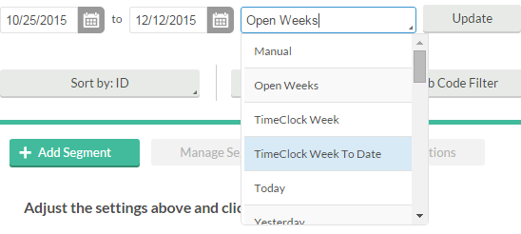

Click Download to see the output options.

Which Download option should you choose?
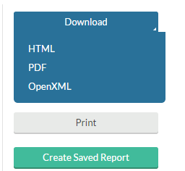
HTML …to view the report on your computer.
PDF … to print the report on paper.
Office OpenXML …to open the report as a spreadsheet in Excel.

Other reporting tools not in the Period Reports menu:
Tools > Employee Status can be used to see information such as who is currently clocked in, who is currently on break, and hours and long shifts.
Tools > Other Tools > Incomplete Clock Operations Log shows when an employee logs into RealTime, but fails to complete a clock operation.

Employee Filter
Click the Employee Filter button. Use the checkboxes to select the criteria to filter on, then enter values under Include or Exclude.
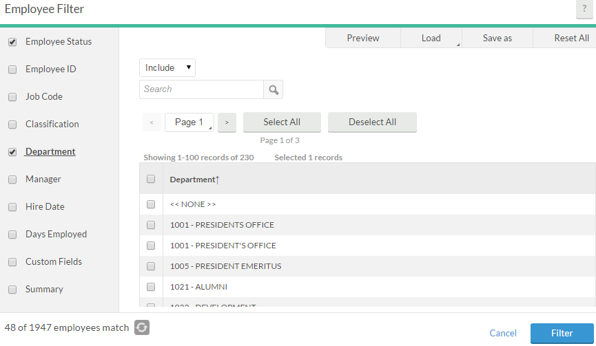
For example, to view only the employees of one particular department, click the check box next to Department, then enter the department name in the Search box, and click the check box next to the department.
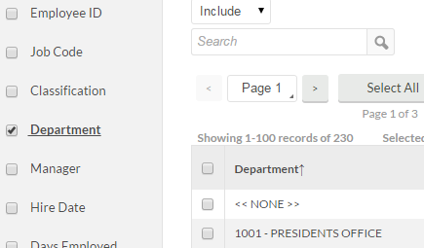
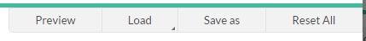
In the lower left corner of the Employee Filter window, there is a running display of the number of employees that will be selected under the current criteria. Click the refresh button to update this number.
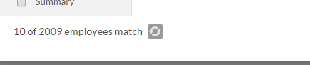

To see the records that will be included in the report, click “Preview.” To save the report to use again, click Save as and give the filter a name.
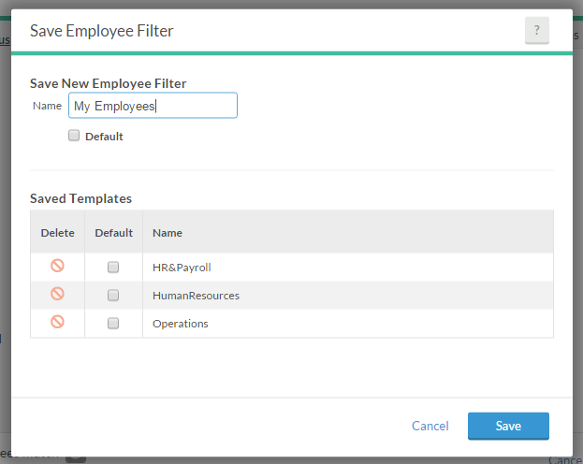
Once it has been named and saved, a filter is available throughout the system. For instance, if you edit and save criteria in Period Reports, you can later load that same filter when viewing Request Manager under the Tools menu or Group Hours under the Hours menu.

Options
Click Options to view the Period Report Options: Formatting Options, Miscellaneous, and Print Options.
Formatting Options: Date, time, and name display formats may be changed from their defaults here.
Miscellaneous: Choose one or more fields to sort by.
Print Options: Choose colors and formatting for the printed report.
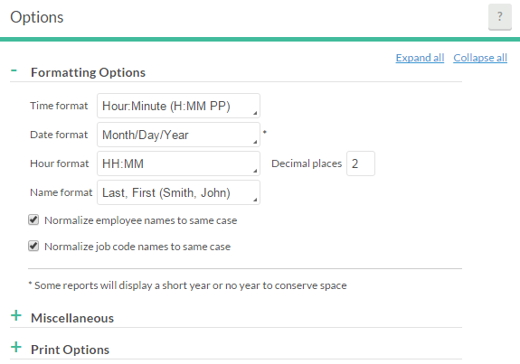
Settings
The Settings menu will display a list of options specific to the report that is currently selected. Some reports have more options than others.

Messaging
The messaging feature allows messages to be sent to employees which are viewed during a clock operation.

To send an individual message:
1. Click the envelope icon in the upper right corner.
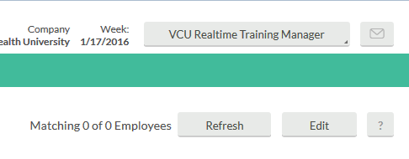
2. Click Select recipients. Use a filter or Select employees from list by checking the box next to each employee you wish to send the message to. When you are finished selecting employees, click Select recipients.
3. Enter the Message you wish to send in the box. Check the Message starts and/or Message expires boxes if you want the message to display only during a specified time period.
4. Click Send to send the message to the employee(s).

To Review Message Status:
1. Go to Employee > Messaging.
2. Place a check next to the employee and click History.
3. A list of all individual messages sent to this employee will appear with the status: Not Read or [date read].

Glossary
- Break – time not worked for lunch or meal. Meal breaks are unpaid, and non-exempt employees should clock out for the meal break using the “Break” button and not the “clock out” button. This is not the discretionary “15-minute” break that some departments may permit.
- Clock in – a clock in initiates the system to record an employee’s hours worked. Clock in is used at the start of a work day or shift and after returning from a meal break and is similar to the “time in” term used on the paper timesheet.
- Clock out – a clock out ends the system tracking of an employee’s hours worked. It is only used at the end of the work day or shift and is similar to the “time out” term used on the paper timesheet.
- Conflicting shift – a shift that overlaps with another. Most often, conflicting shifts are the result of an employee working during a time when leave was loaded for a holiday or office closing.
- Designee – managers at the dean level or above have the option to identify a full designee in RealTime who will complete all time and leave approvals and other responsibilities (apart from approving their own time and leave). Other managers have the option to identify an exception designee who will complete time and leave approvals on an exception basis. In cases where a designee is identified, BOTH parties are responsible for accurate and timely approval of employee time and leave and the supervisor retains final responsibility. Appointing a full designee requires that the VCU RealTime Supervisor-Designee Information and Request form be completed by the supervisor, signed by the supervisor and designee, and approved by Human Resources. An exception designee may be appointed by the supervisor through the RealTime Designee online portal.
- Exempt employee (FLSA-exempt employee) – an employee who is exempt from regulation under the Fair Labor Standards Act (FLSA). All faculty are FLSA exempt; exempt classified employees must meet standards for exemption from FLSA. Exempt employees use VCU RealTime only to request and track leave.
- Hourly employee – an employee whose wages are based on the number of hours worked, not a total salary. Hourly employees include student workers and work-study students. Hourly employees who work more than 40 hours in a week must be paid overtime.
- Job code – time is captured and tracked with job codes. Job codes include a REG code for each non-exempt employee, and codes for each of the leave and earn codes the individual employee is eligible to use.
- Missed punch – employee failed to either clock in for work, clock out after work, clock out for a meal break or clock in upon returning from a meal break.
- Non-exempt employee (non-FLSA-exempt employee) – an employee who does not meet the requirements for exemption from regulation under the Fair Labor Standards Act (FLSA). Non-exempt employees must be compensated at a rate of one and one-half times for hours worked over 40 in a work week.
- Proxy – a person identified within a department as a back-up for the timekeeper who is trained and authorized to perform timekeeper responsibilities when the appointed timekeeper is unable to do so.
- RealTime employee number – an employee’s unique identifier in RealTime, found by replacing the V in the VID with a 9 (e.g. an employee whose VID is V00123456 would have the RealTime number 900123456).
- Segment – the length of time from a “clock in” action until a “clock out” action. For example, most full-time employees will have two segments each day, one before the meal break and one after. Segments can be edited, added or split. Segments cannot be deleted.
- Time Clock Week – the oldest active week in RealTime.
- Time Sheet – Record of time worked and approved leave. Non-exempt employees who do not clock in and out use the “Manage Time Sheet” function to record their hours worked in RealTime.

Notes

hr.vcu.edu

